SR1 Building preparation

Request for power distribution in test-, assembly-, rack-, laser area of SR1
ATLAS Project Document No: | Institute Document No. | Created : 6/03/02 | Page: 1 of 5
ATL-.... |  | Modified : 26/03/02 | Rev. No .: 2.0

SR1 Building preparation

Request for power distribution in test-, assembly-, rack-, laser area of SR1

Draft 2

Prepared by:  ID SR1 working group | Checked by:  ID SR1 working group | Approved by:  IDSG
Distribution List
ID-SR1 working group, SCT,TRT,PIX

ST/EL planned installation

This document is based on already existing power distribution plans by ST/EL for the ID integration rooms in building Bat 2175. Approximate locations are shown in drawing 1.

At present the following is planned by ST/EL

Assembly area:
- 4 blocs coffrets:
  - 1x32A tetrapolaires
  - 1x16A tetrapolaires
  - 4x10A mono Feller

Test area:
- 1 blocs coffret:
  - 1x32A tetrapolaires
  - 1x16A tetrapolaires
  - 4x10A mono Feller
- 1 coffret 4x10A Feller

Laser room:
- 1 blocs coffret:
  - 1x32A tetrapolaires
  - 1x16A tetrapolaires
  - 4x10A mono Feller
Control room:
- 2 coffrets 4x10A Feller
Rack area:
- 4 blocs coffrets:
  - 1x32A tetrapolaires
  - 1x16A tetrapolaires
  - 4x10A mono Feller
- Supply of 65 racks in 5 rails type Canalis-100A
- Supply, installation and connection of 6 general A.U.
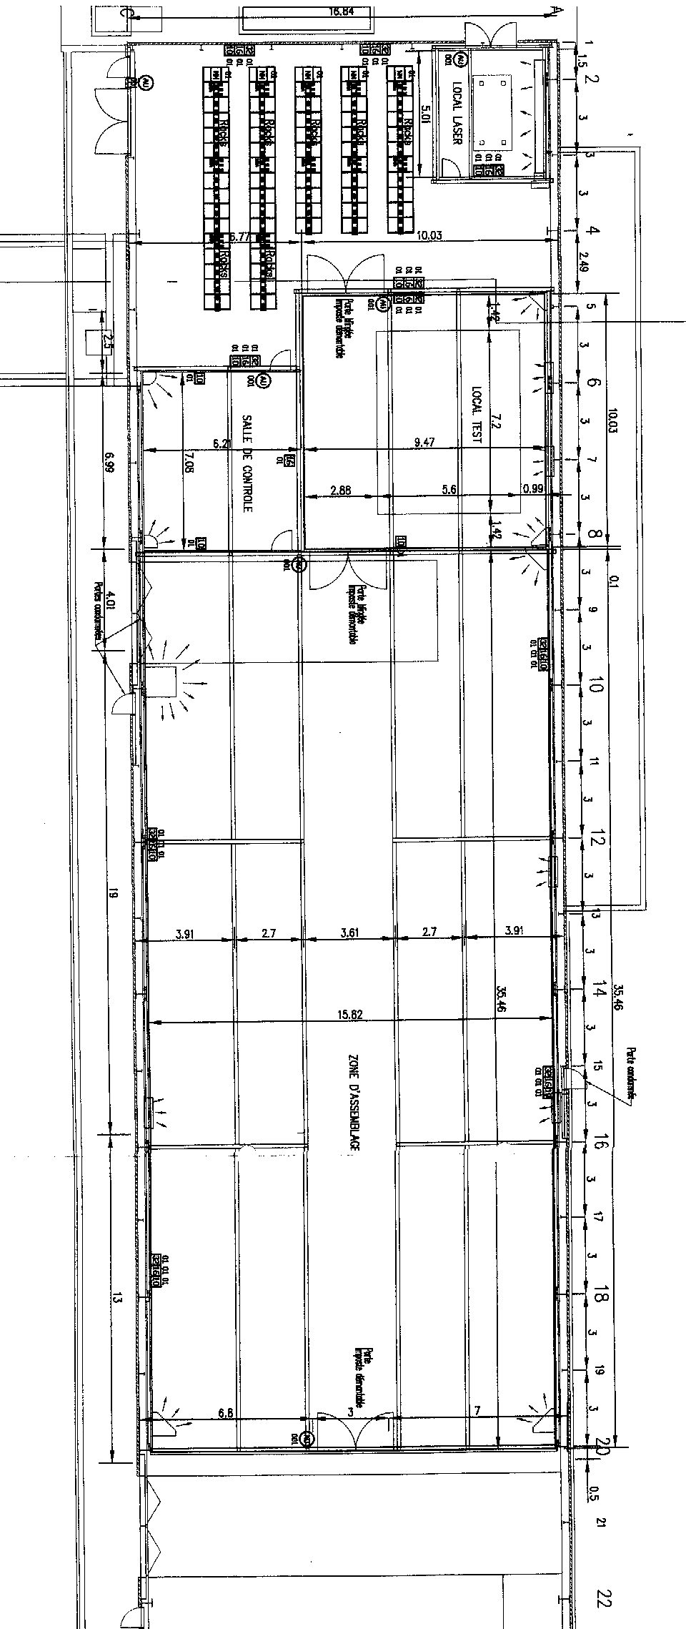
Drawing 1: Original proposed power distribution
Requested Modifications:

Our request for modifications concern location of power distribution and, where applicable, number of connections. Proposed modified locations are shown in drawing 2.
The distribution is based on 3 basic type of outlets (as proposed previously)
  - 1x380V/16 3-pol (denoted as block "A" in drawing 2)
  - 2x220V/16A mono-phase (denoted as block "B" in drawing 2)
  - Feller 4x220V/10A mono-phase (denoted as block "C" in drawing 2)

Locations in drawing 2 are shown approximately and numbered for clarification.
Detailed specifications of each outlet are specified in table 1.

Special UPS-circuit (outlets 24-29):
In assembly area and test area we require 1 circuit, which is backed by UPS power. This was not previously forseen. This circuit is to be connected to one identified point in the main distribution in the rack area, where the UPS can then be connected. (The UPS is to be provided by the ID). On this special UPS-circuit we require 6 outlets (2 in test area and 4 in assembly area). The UPS-circuit outlets shall be (if possible) of type Feller 4x220/10A). Their location is shown in "red" on drawing 2.

Outlet on building outer wall (outlet 5):
For the connection of evaporative cooling components placed outside SR1 we require one exterior outlet as secified in item outlet 5 of table 1.

Summary
Test area: 2 x (1x380/16 & 2x220/16 & 4x220/10) + 1x (4x220/10)
Assembly area: 2 x (1x380/16 & 2x220/16 & 4x220/10) + 3x (2x220/16 & 4x220/10) + 1x(2x220/16) + 4x (4x220/10)
Airlock: 1x (4x220/10)
Control room: 1x (2x220/16 & 4x220/10) + 2x (4x220/10)
Rack area: 3 x (1x380/16 & 2x220/16 & 4x220/10)
Laser area: 1 x (1x380/16 & 1x220/25 & 4x220/10)
Outside cooling and gas: 1 x (1x380/16 & 1x220/25 & 4x220/10)
UPS backed circuit: TA 2x (4x220/10) + AA 4x (4x220/10)

- Supply of 65 racks in 5 rails type Canalis-100A (unchanged)
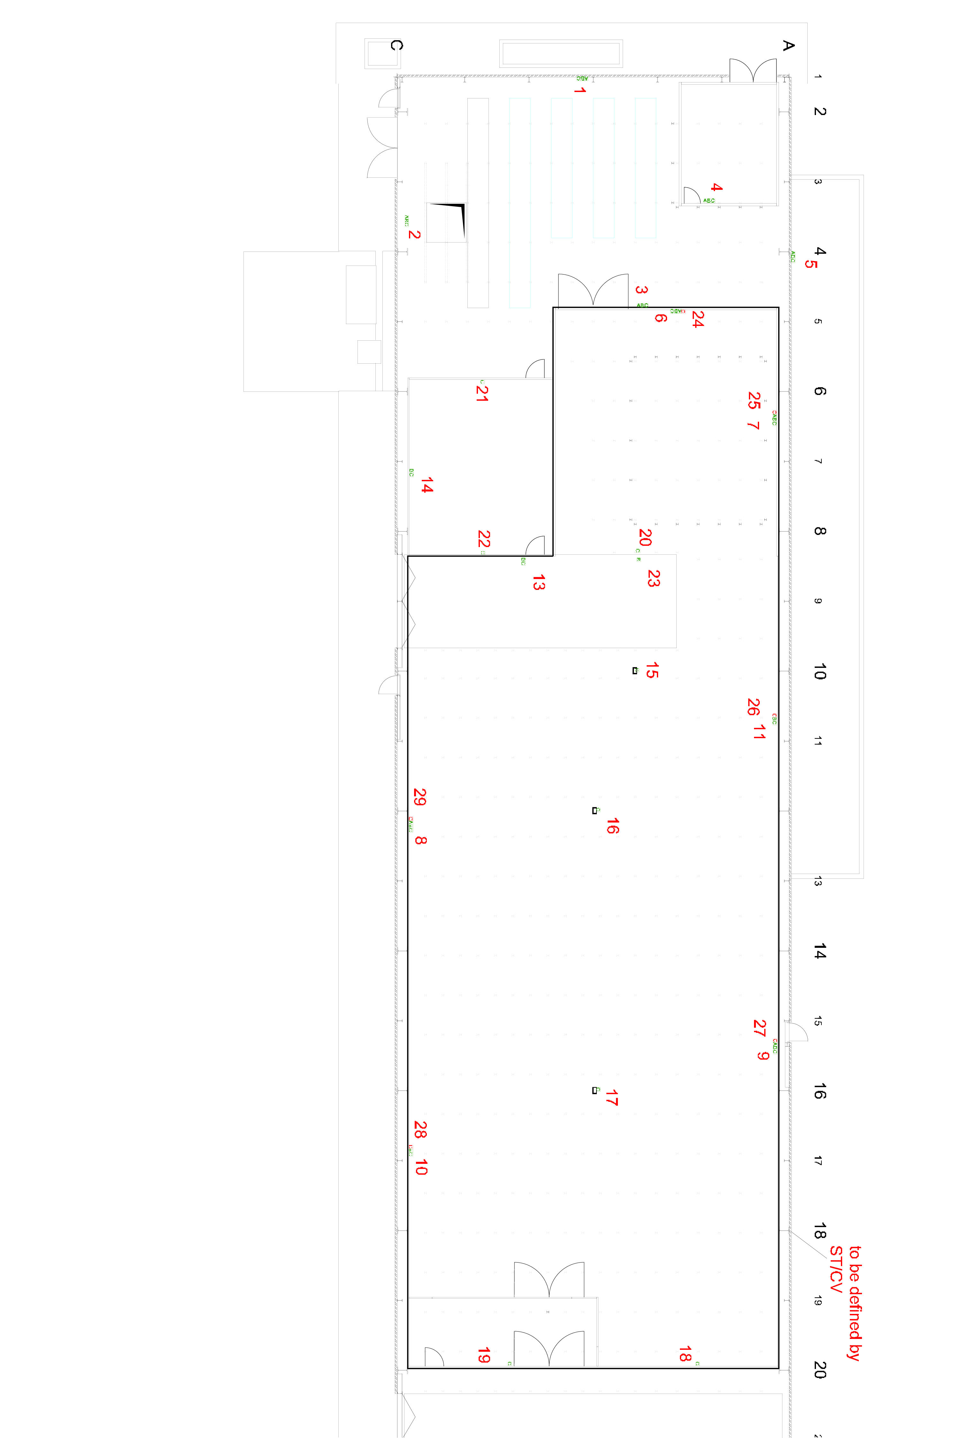
- Supply, installation and connection of 6 general A.U. (unchanged)
Drawing 2: Approximate locations of requested power distribution (additional
connections are highlighted in red)
Additional CLEAN ground connection in assembly and test area

For special grounding of part of our (electrically sesitive) detector parts we request a new, clean ground connection cable which is otherwise not used by any equipment. This gound should be available along the walls in assembly and test area and connected to a ground pit (unused if available). This clean ground shall be insulated from metal structures of the building. Connection tab to it shall be provided every 8 to 10m if possible.

Table 1:
Overview of outlet location

Outlet number as in drawing 2.

